HARVELELECTRIC ELECTRONIC STORE

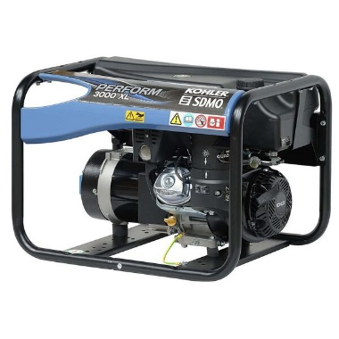

Navigator 5.5kva Key Start Generator With TimerSwitch-NG3990

Brand: [Sumec](https://www.jumia.com.ng/sumec/)

**Price: $7350**

Was ~~$8000~~ 54%

+ shipping only for V.V.I.P clients.

## **Product details**

* Timing switch tech and navigator mega tank, enable you to embrace quality sleep and save the trouble of fueling or turning off the general every night.
* You can time your generator to start and off time giving your generator total control without you going close to it.
* 100% copper USA STANDARD
* 20HR RUN TIME (AT 75% LOAD)
* MEGA TANK OF CRAFTSMANSHIP -save fueling trouble and enjoy extra 5hours running time
* FOLDED-DOWN HANDLE DESIGN-more ergonomic, more energy-saving
* EPIC TIMING SWITCH TECH -embrace quality sleep and say no to manual off-gen
* WEIGHTLESS built-more moveable with never-flat wheels.
* Key start feature included
* Petrol/Gasoline Generator
* Get yourself a timing switch generator and worry less about waking up or going to put off your generator at night
* A must buy for every home.
* More comfort, durability, elegance, stylish design, grand yellow,
* With proper unboxing and the careful reading of the manual before usage, it becomes easy to use.
* Low Fuel Consumption

## **Specifications**

## **KEY FEATURES**

* NG3990E
* 20HR RUN TIME (AT 75% LOAD)
* MEGA TANK OF CRAFTSMANSHIP -save fueling trouble and enjoy extra 5hours running time
* FOLDED-DOWN HANDLE DESIGN-more ergonomic, more energy-saving
* EPIC TIMING SWITCH TECH -embrace quality sleep and say no to manual off-gen
* WEIGHTLESS built-more moveable with never-flat wheels.
* 100% copper
* Time your generator
* Key start feature included
* Petrol/Gasoline generator
* Low Fuel Consumption

## **WHAT’S IN THE BOX**

* Generator
* Tires
* Bolts

## **SPECIFICATIONS**

* **SKU**: SU477HL0STR6TNAFAMZ
* **Product Line**: Kris Intercontinental Ltd
* **Model**: NG3990E
* **Weight (kg)**: 30
* **Color**: BLACK
* **Main Material**: Copper
* **Area of Use**: Home Office | Garden | Outdoor
* **Shop Type**: Harvel Electric Store